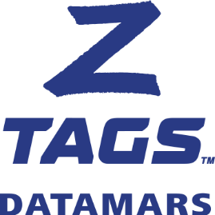

**Z1 NO-SNAG-TAGGER**

**Product Description**

Designed to apply Z1 No-Snag-Tags, the Z1 No-Snag Tagger™ features a flip-out pin for fast and easy tag release. This greatly reduces the risk of ripped or torn ears while contributing to faster healing and improved tag retention. It also enhances the health and safety for the farmer.

The Z1 No-Snag Tagger has easy-grip handles, and is lightweight and durable. Made from glass-filled nylon construction, it weighs just 170 grams. It is strong, durable and reliable and is highly recommended for tagging cattle or sheep.

The Z1 No-Snag Tagger comes with a spare pin in the lower handle.

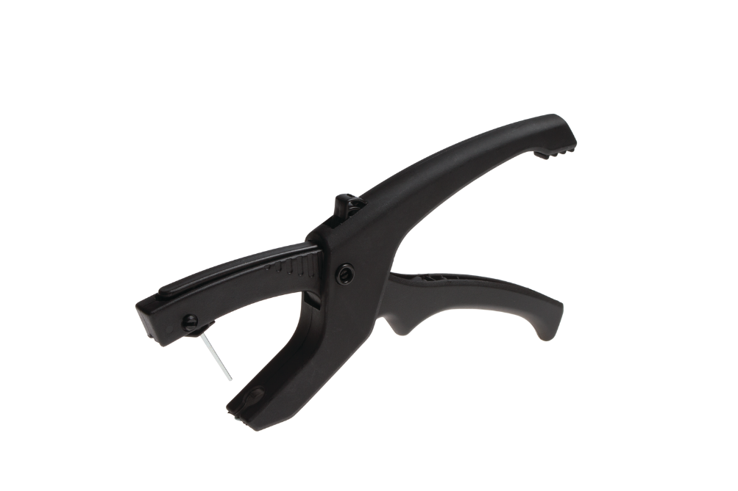

**Technical Specifications**

|  |  |
| --- | --- |
| Dimension (L x W x D) | 260 mm x 135 mm x 25 mm |
| Weight | 170 g |
| Product code | 700 2501-020 |